**DAILY ONLINE ACTIVITIES SUMMARY**

|  |  |  |  |  |  |  |  |
| --- | --- | --- | --- | --- | --- | --- | --- |
| **Date:** | 27/05/2020 | | | | **Name:** | Anusha. K | |
| **Sem & Sec** | 4th SEM SECTION 'A' | | | | **USN:** | 4AL18CS009 | |
| **Online Test Summary** | | | | | | | |
| **Subject** | | Object Oriented Concepts(18CS45) | | | | | |
| **Max. Marks** | | 30 | | **Score** | | 22 | |
| **Certification Course Summary** | | | | | | | |
| **Course** | Cloud foundations | | | | | | |
| **Certificate Provider** | | | GreatLearning Academy | **Duration** | | | 4.5 hours |
| **Coding Challenges** | | | | | | | |
| **Problem Statement:** **1.** Given an array A of size N where the array elements contain values from 1 to N with duplicates, the task is to find total number of subarrays which start and end with the same element. | | | | | | | |
| **Status:** Completed | | | | | | | |
| **Uploaded the report in Github** | | | | YES | | | |
| **If yes Repository name** | | | | <https://github.com/anusha20219/Lockdown-coding> | | | |
| **Uploaded the report in slack** | | | | YES | | | |

**Online Test Details:**

The online test was from module 5 which was about the Event Handling and Swings. There were 30 questions and the duration was 30 mi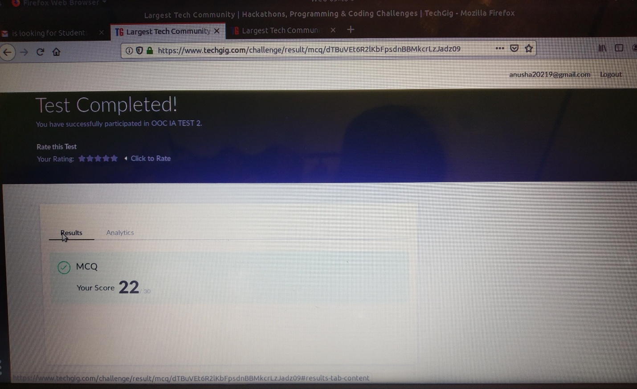ns.

**Certification course details:**

**Topics covered are:**

* **History and evolution of cloud**
* **The classical enterprise**
* **Myths of cloud computing**
* **Service delivery models**
* **Degree of abstraction**
* **Cloud attributes**
* **Service Offerings**
* **Managed Services**
* **Subscriptions**
* **Cost economics**
* **Elasticity**
* **Virtualization**
* **Evolving to PaaS**
* **Next generation virtualization**
* **Face-off – VM vs Containers**
* **Cloud service taxonomy**
* **Overview of infrastructure automation**



**Online Coding Details:**

**Problem statement 1: Given an array A of size N where the array elements contain values from 1 to N with duplicates, the task is to find total number of subarrays which start and end with the same element.**

